Restaurants
Exclusive Benefits for ITSO members
La Cabana
Macher
Debbie and Darren
0034 650685662/646523089
www.lacabanamacher.com

Grillen
Tinajo
Morten, Richard and Tarnya
0034 619 239 095
www.grillen.es

Verde Mar
La Santa Village
Debbie
0034 928840858/630152860
www.verdemarlasanta.com

Mezza Luna
Tinajo
Italian
Lorenzo and Donato
0034 928840141

Mama Africa
La Santa Village
Modern International
Monica
0034 928838104/686620521

Rio Azul
Club La Santa
Spanish menu
0034 928840327

Los Aljibes
Bravo Murillo, Tahiche
00 34 610 45 42 94

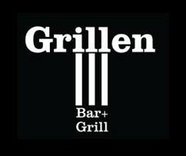
+34 928 84 03 27

La Plaza
Club La Santa
0034 928599999
(CLS Reception)

Atlántico
Club La Santa
Self-service buffet
0034 928599999
(CLS Reception)

Bar Piscina
Club La Santa
Extensive menu
0034 928599999
(CLS Reception)

El Lago
Club La Santa
Extensive menu
0034 928599999
(CLS Reception)

